Nios Avalon Uart with FIFOs
11/19/03 updated 6/14/06

Abstract
The Nios UART is a great little UART. It is much smaller than the 16550 style UARTs. However many times it would be handy to have input and output FIFOs. I have created a New UART base on the standard Nios UART which does exactly that

Introduction
This extended UART is based on the Altera Avalon UART for the Nios processor. In fact, with no special features selected it should generate the same exact Verilog and VHDL. Simulation works the same as the standard Nios as well.

Installation
Unzip the Fifoed_avalon_uart.zip file. Place the folder Fifoed_avalon_uart in to the components directoy usually found at
C:\altera\kits\niosX.X\components
Make sure that you don’t have too many folders named Fifoed_avalon_uart. Then next time you launch SOPC builder you will have a new component in the communications sections calledn Fifoed Uart ( it will be changed in the future )
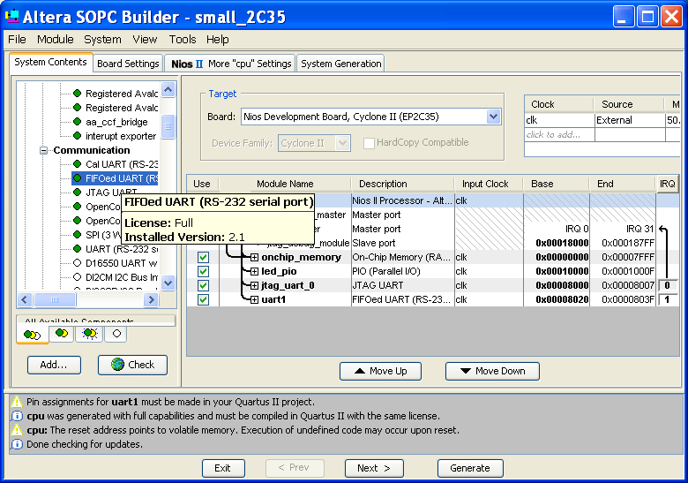

Changes

GUI
The only change to the GUI is the addition of the FIFO and MISC tab. In the FIFO Tab you have three options.
- First to use FIFOs or not. If you do not include FIFOs you will generate a standard Nios UART.
- Export FIFO used signals. The option allows you to export ( send out to the SOPC top level) the “used” signals on the fifo. In other words these signals tell how many words/chars are currently sitting in the transmit or receive fifos. This is helpful if you want to say – do hardware handshaking automatically. You could add logic externally that could watch to see is the fifo is say 75% full then it would deassert RTS. ( all external logic) Another thought—logic could be created to through and interrupt when the FIFOs get at a certain threshold. Again you can do anything you want with these.
- FIFO depth. You can select how many words you want to store in the FIFOs.
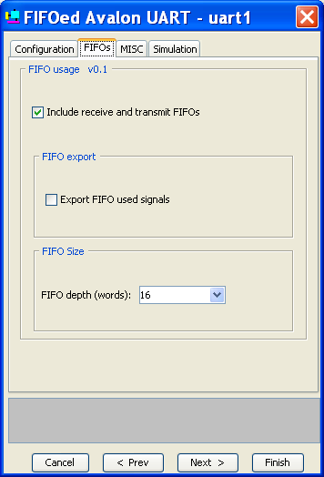
In the MISV tab you have the following options
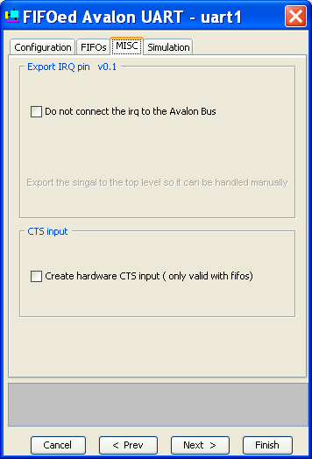
- The first option allows you to export the IRQ signal instead of connection it through the Avalon switch fabric. This is a rare situation.
- Unlike the CTS and RTS on the first tab this is actual hardware which controls the flow control.

INPUT and OUPUT FIFOs
The FIFOs are created using memory blocks available on the ALTERA parts. QuartusII will auto choose which memory is appropriate. The size may vary from 4-4K words ( chars if they data width is 8 bits).
Software Interface
The software interface to the UART is exactly the same as for the normal Nios documentation. The fifo are transparent to all the standard Nios software routines. The only difference from the printed UART documentation are as follows
- trdy only goes low when the when the entire fifo is full.
- Roe only is asserted if the receive fifo is full and a new char arrives.
- Toe only is asserted if the fifo is full and you try and write addition chars to the buffer.
- Two additional registers have been created if you use the FIFOs so you can see the status of the FIFOs.. The are read only and writes have no effect. They indicate the number of chars in the tx or rx fifo.
  - uartrxfifoused address 6
  - uarttxfifoused address 7

Simulation
You may simulate this uart exactly like the standard Nios UART and it has all the same nice features. However this standard simulation bypasses a lot of the UART logic. To simulation the UART completely do the following.
- Replace `ifdef MODEL_TECH with `ifdef MODEL_TECH1
- Remove the comments from in front of
  - // assign source_rxd = rxd;
  - // assign divisor_constant = 434;
- Also you may want to change the divisor to something much smaller like 40 or less.
Now you will simulation the “real” hardware.

